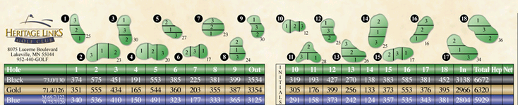

$75 Entry fee ($40 member & PCC) includes cart and prize money.

Skins game available for most events. Prizes paid at the conclusion of each event. Beer and drink specials available during and after the tournament.

For registration and information

Call the Heritage Links Pro Shop: (952) 440-4656

**All players must have an established handicap! If a player does not have an established handicap they must talk to the Golf Professional prior to the tournament.**

2023 Summer of Champions

*Tournament Schedule*

**Sunday, June 11th Two Person Best Ball**

* Tee times starting at Noon
* **Each player plays their own ball - lowest score (both gross score and net score)**

**Sunday, July 23rd The Cottonwood**

* 3 Person Scramble (Cottonwood Rules)
* Tee times starting at Noon
* Added $120/tm Big Game buy-in

Cottonwood Rule: **Everyone tees off and your team plays a scramble. If you are in the fairway, on the green or the collar, all players hit from that spot. If your team is not fairway/green/collar ONLY the person who has chosen to play can hit and ONLY that person will play until they are back on one of those surfaces.**

**Sat-Sun, Aug 19-20 Heritage Links Club Championships**

* $100 entry ($60 members & PCC)

**Sunday, Sept 24th Two Person White (forward) Tee Scramble**

**Saturday, Oct 14th Heritage Links Fall Classic “Big Cup”**

* **1 score on Par 3s, 2 on Par 4s, 3 on Par 5s**
* **$100 entry ($75 members & PCC)**